UNEP Emissions Gap Report 2025

Chapter 2 Global Emissions Trends - Technical Appendix

**Lead Authors**: William F. Lamb1,2, Minal Pathak3

1 Potsdam Institute for Climate Impact Research (PIK), Member of the Leibniz Association, Potsdam, Germany

2 Priestley Centre for Climate Futures, University of Leeds, United Kingdom

3 Ahmedabad University, India

### Uncertainties and methodological choices

Uncertainties in emissions estimates are reported following the IPCC AR6 Working Group III assessment of ±8% for fossil CO2, ±70% for LULUCF CO2, ±30% for CH4 and F-gases, ±60% for N2O [(Dhakal et al., 2022)](https://www.zotero.org/google-docs/?115fsT). Reflecting these uncertainties, global emissions estimates are rounded to the first decimal place of billions of tons of CO2 equivalent, while current national emissions estimates are reported to three significant figures in millions of tons of CO2 equivalent. Rates of change are reported to the first decimal place and fractions are rounded to the nearest 1. Chapter 2 follows a territorial-based accounting of emissions (i.e. emissions are allocated to the sectors and nations where they occur) unless otherwise noted. The latest years of emissions data should be treated as preliminary - particularly in the case of LULUCF CO2 and non-CO2 GHG emissions - due to the use of provisional methodologies based on available activity data. Emissions are generally reported up to 2024. However, due to data limitations, this is not possible for inventory-based LULUCF CO2.

### Comparison of estimates to previous Emissions Gap Reports

The EDGAR and the Global Carbon Budget datasets are updated on a yearly basis using the latest available statistical information. These updates not only add additional years of data as it becomes available, but they also apply revisions to previously published data. This implies changes compared to prior reporting in the Emissions Gap Report, as summarized in Table 2 for the year 2019. While differences can be substantial, particularly for non-Fossil CO2 emissions, they all lie within the standard uncertainty ranges used by Chapter 2.

| GtCO2e | Emissions Gap Report 2022 | Emissions Gap Report 2023 | Emissions Gap Report 2024 | Emissions Gap Report 2025 |
| --- | --- | --- | --- | --- |
| GHG | 56.4±5.4 | 56.9±5.6 | 55.9±5.5 | 54.6±5.1 |
| Fossil CO2 | 38±3 | 37.8±3 | 38.1±3 | 38±3 |
| LULUCF CO2 (Bookkeeping) | 3.8±2.7 | 4.6±3.2 | 4.6±3.2 | 3.79±2.7 |
| LULUCF CO2 (Inventory) | -1.9±-1.3 | -2.4±-1.7 | -2.8±-2 | -3.55±-2.5 |
| CH4 | 10.6±3.2 | 10.5±3.2 | 9.3±2.8 | 8.95±2.7 |
| N2O | 2.6±1.6 | 2.6±1.5 | 2.5±1.5 | 2.49±1.5 |
| F-gases | 1.4±0.42 | 1.4±0.42 | 1.4±0.42 | 1.41±0.4 |

**Table 1: Emissions in 2019 as reported in previous Emissions Gap Reports**

### On the use of national inventories versus third party emissions data

Chapter 2 of the Emissions Gap Report provides estimates of greenhouse gases up to one year prior to publication (this year: up to 2024). One of the challenges in providing this timely update is that national emissions inventories (hereafter ‘inventories’) are not usually available for the prior year at the time of publication. The National Inventory Reports (NIRs), published by Annex I countries, and the Biennial Transparency Reports (BTRs), published by all countries, typically include emissions up to two years prior. In addition, submitted BTRs are not always complete in terms of gases, sectors and years, or are simply not available for all countries (see Box 3 in Chapter 2).

As a result, the analysis in Chapter 2 relies on third-party data to track global, national and sectoral emissions. Table 2 describes a selection of third-party datasets. The choice of EDGAR as the primary dataset for GHG emissions in Chapter 2 reflects its comprehensive coverage of gases and timely update schedule, which can provide estimates for the prior year at the time of publication.

Besides the timing of inventories and third-party data releases, a key consideration is data quality. It can be argued that compared to third-party data, inventories often use more detailed methodologies and can apply country-specific emissions factors, reflecting considerable national investments in data gathering and analysis. This may especially be the case for Annex I countries, which have accumulated significant experience in reporting inventories. It should be noted that the EDGAR database used in this chapter is predominantly based on Tier 1 emission factors, whereas inventories often use more detailed Tier 2 or Tier 3 emission factors. On the other hand, a number of studies have found that inventories tend to diverge from top-down atmospheric inversions of CH4 emissions, indicating that further improvements are needed in specific sectors such as agriculture, waste and fossil fuel production (Deng et al., 2022; Janardanan et al., 2024; Scarpelli et al., 2022; Tibrewal et al., 2024).

| **Dataset name** | **Version** | **Gases** | **Time period** | **Link** |
| --- | --- | --- | --- | --- |
| Emissions Database for Global Atmospheric Research (EDGAR) | 10 | CO2-FFI, CH4, N2O, HFCs, PFCs, SF6, NF3 | 1970-2024 | <https://edgar.jrc.ec.europa.eu/> |
| Potsdam Real-time Integrated Model for probabilistic Assessment of emissions Paths (PRIMAP) | 2.6.1 | CO2-FFI, CH4, N2O, HFCs, PFCs, SF6, NF3 | 1750-2023 | <https://zenodo.org/records/15016289> |
| Community Emissions Data System (CEDS) | 2025.03.18 | CO2-FFI, CH4, N2O | 1970-2023 | <https://zenodo.org/records/15059443> |
| Global Carbon Budget (GCB) | 2024 | CO2-FFI, CO2-LULUCF | 1850-2023 (national);  1850-2024 (global) | <https://globalcarbonbudget.org/> |

**Table 2: Overview of selected global datasets of GHG emissions.** Note that details are subject to change, as these datasets are in continuous development.

### Data and code availability

The code and data used to produce all emissions estimates in this chapter are available here: [Link].

### 

### Additional Figures

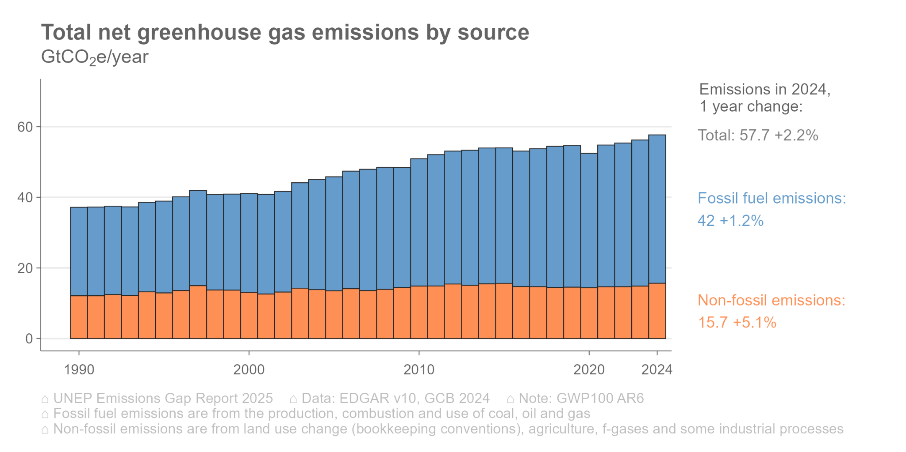

**Figure 1: Total net greenhouse gas emissions by source**

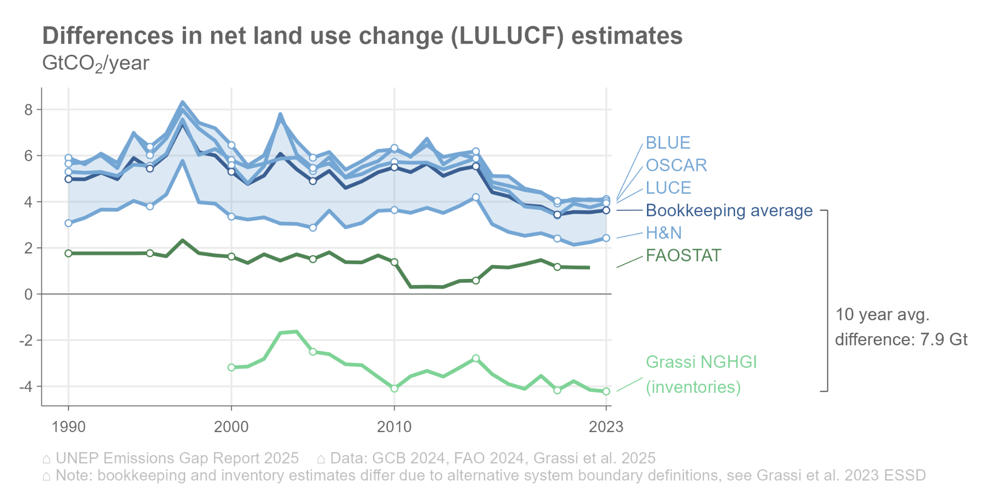

**Figure 2: Differences in net land use change (LULUCF) estimates**

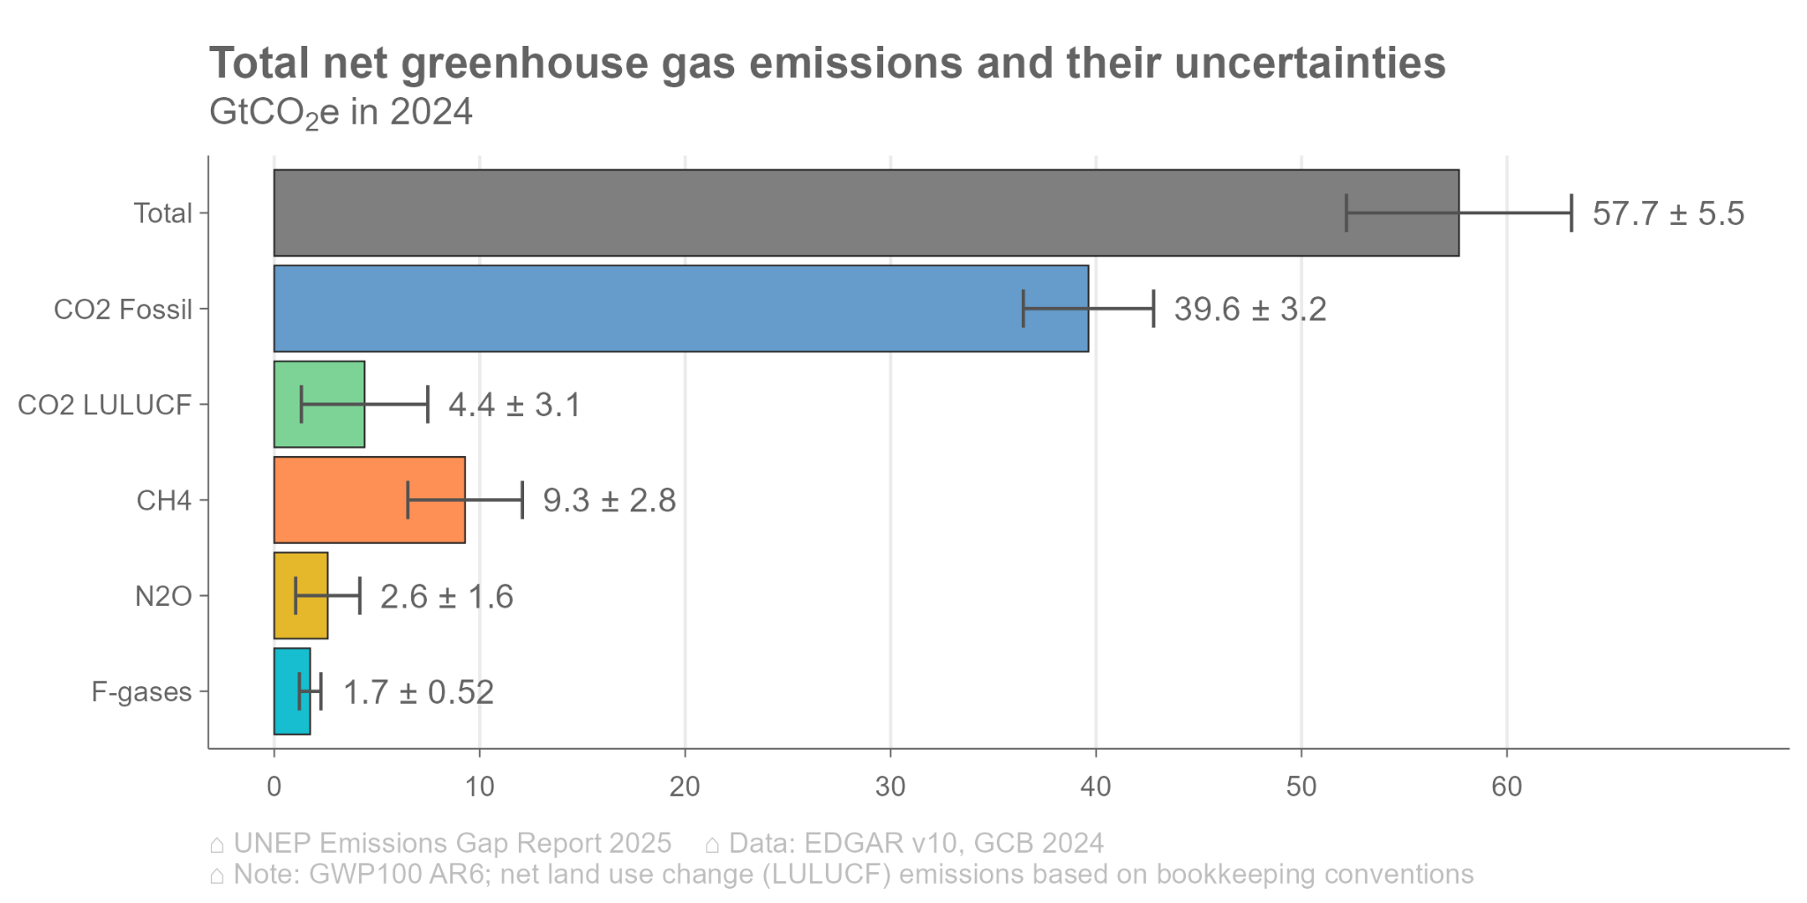

**Figure 3: Total net greenhouse gas emissions and their uncertainties**

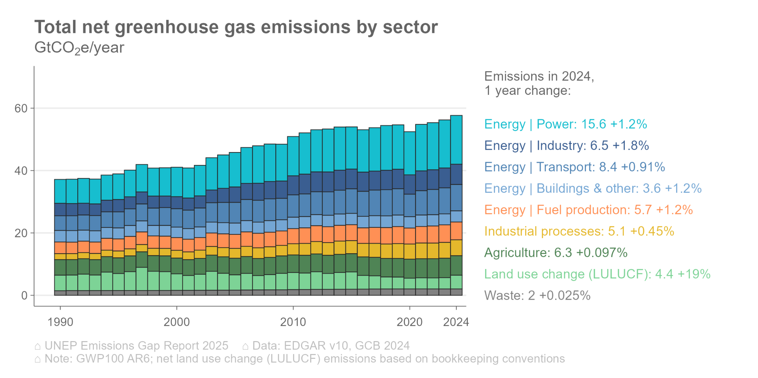

**Figure 4: Total net greenhouse gas emissions by sector.**

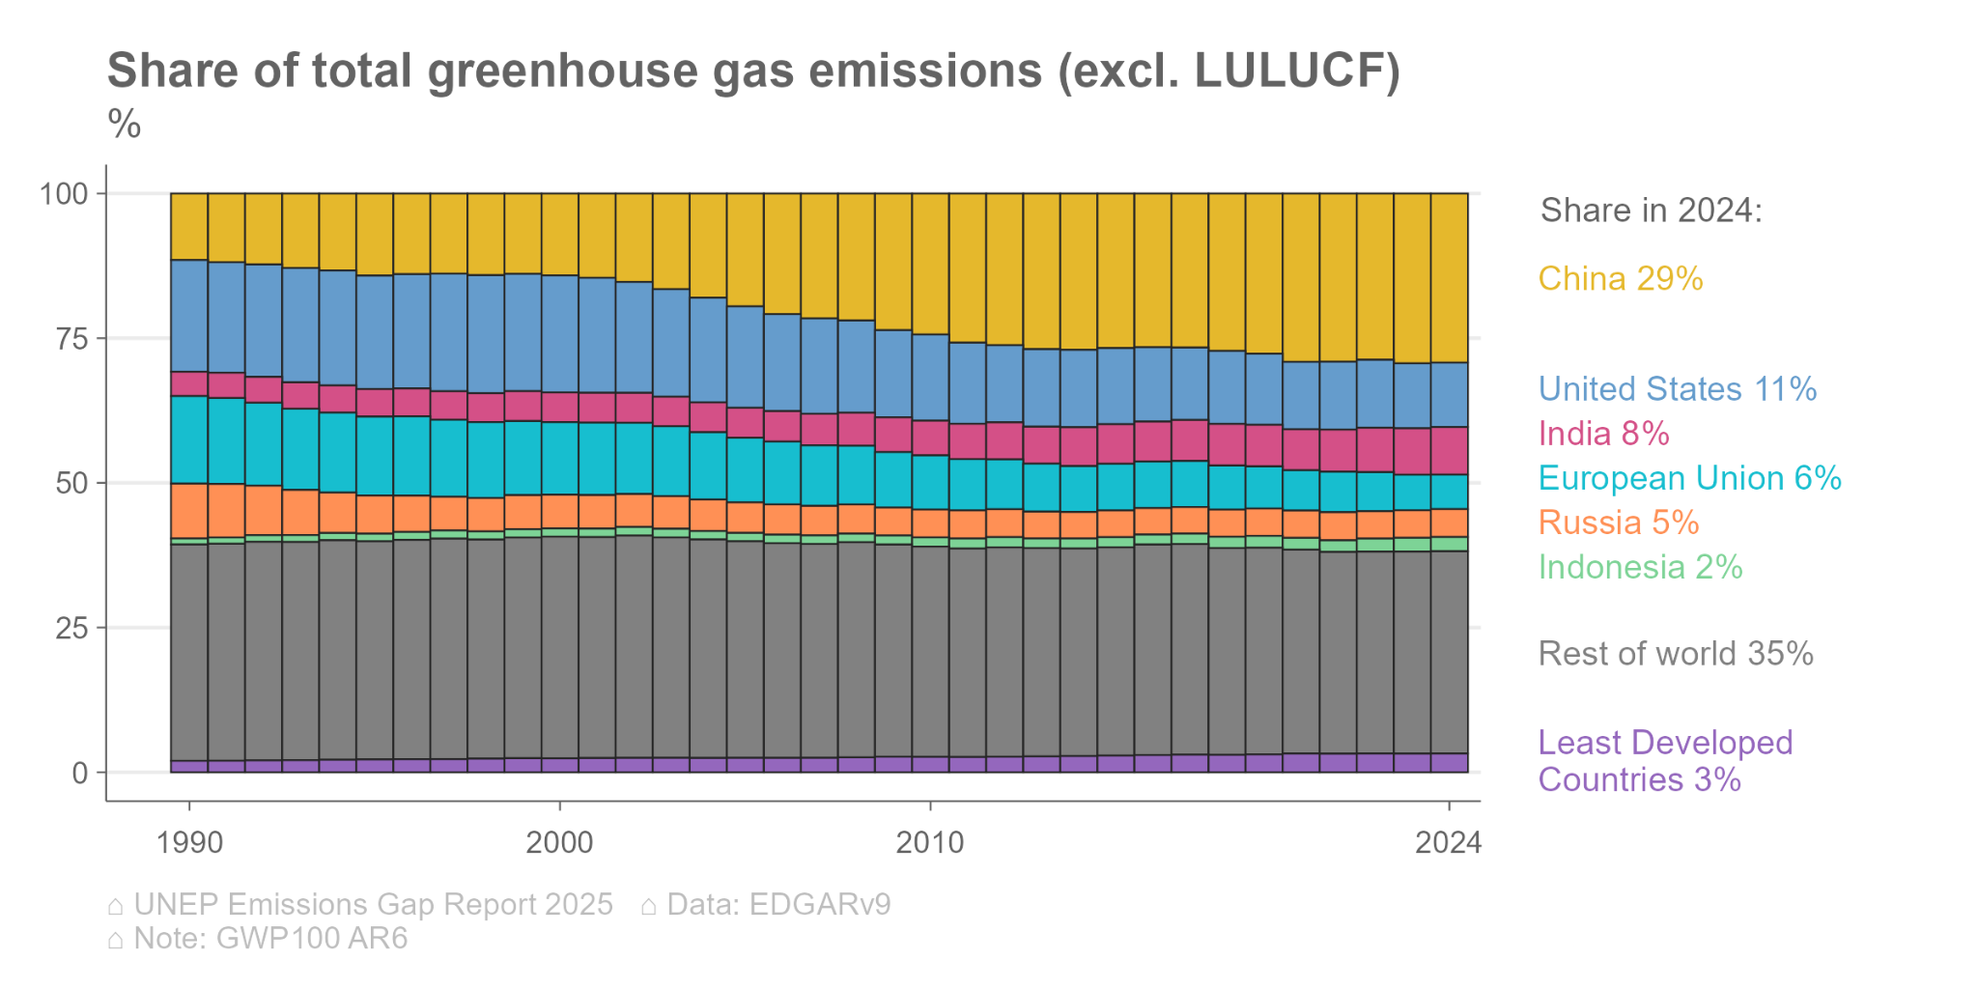

**Figure 6: Share of total greenhouse gas emissions by major emitters, excluding LULUCF**

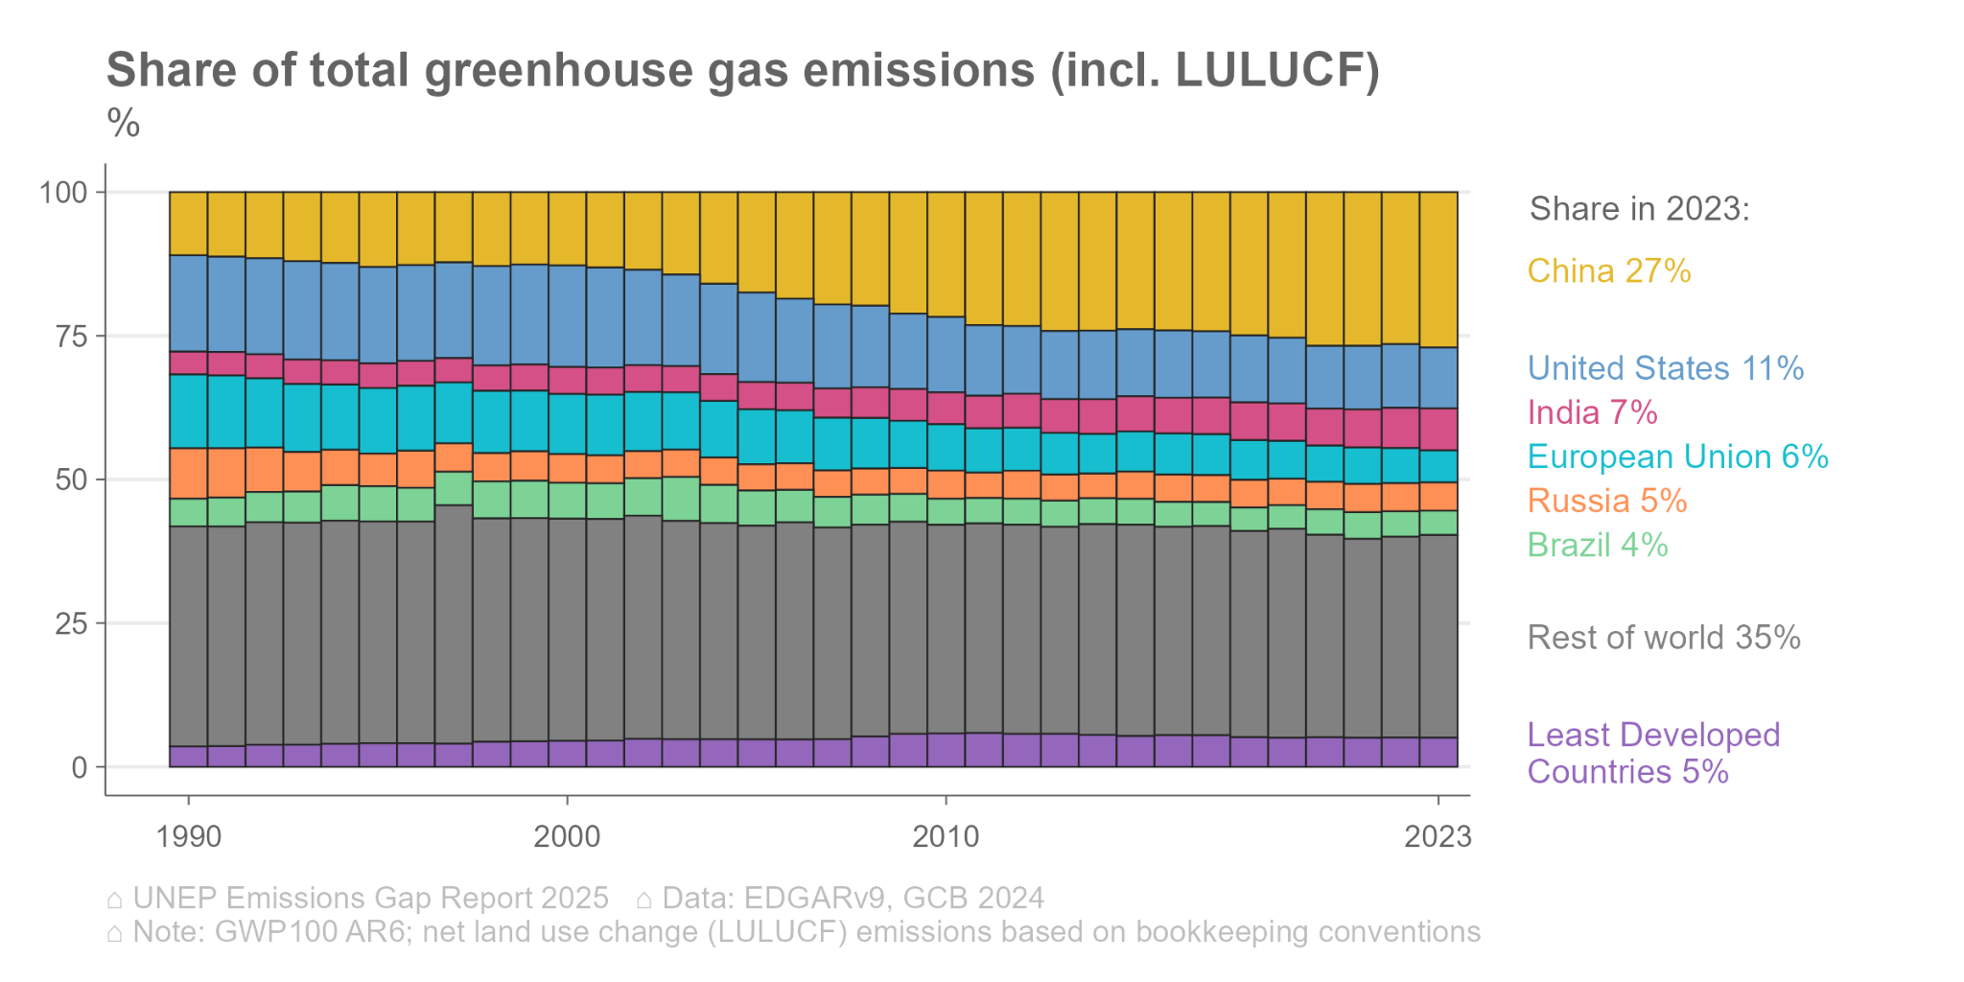

**Figure 7: Share of total greenhouse gas emissions by major emitters, including LULUCF**

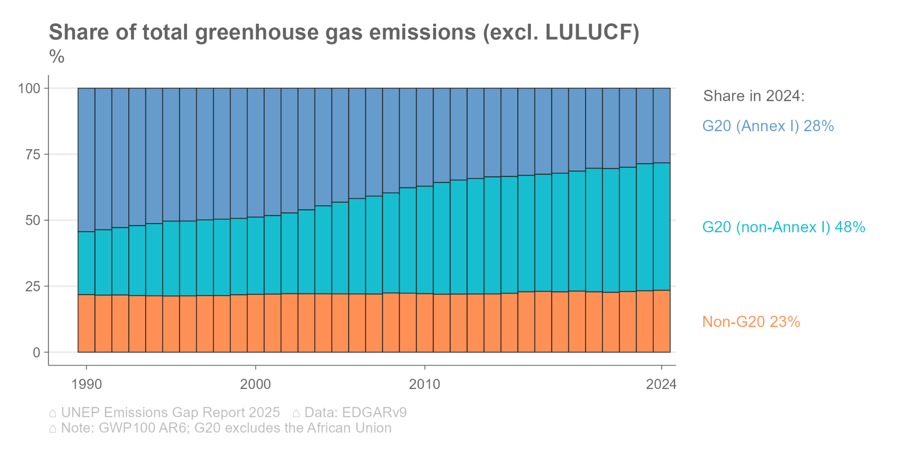

**Figure 8: Share of total greenhouse gas emissions by country category, excluding LULUCF**

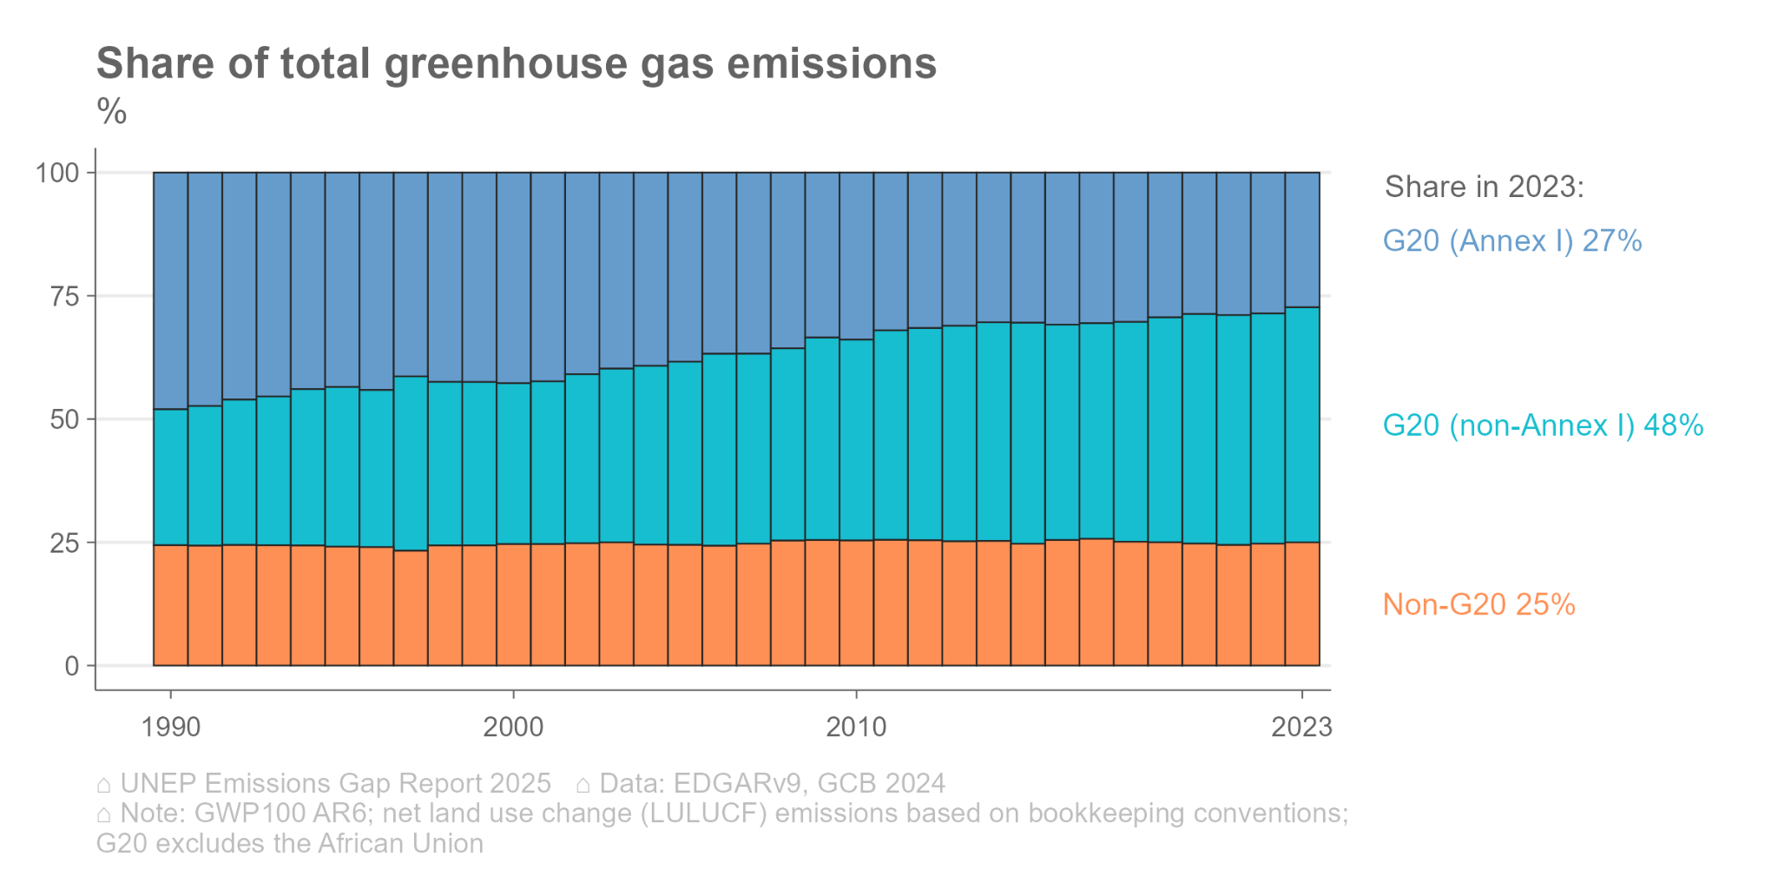

**Figure 9: Share of total greenhouse gas emissions by country category, including LULUCF**

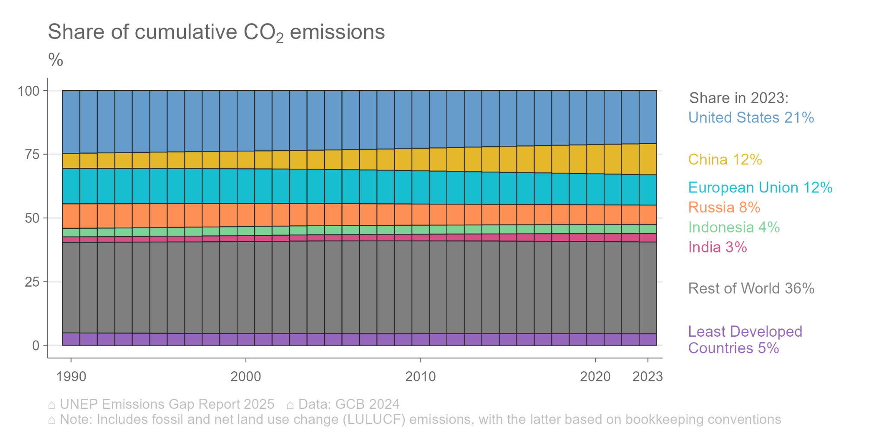

**Figure 10: Share of cumulative CO2 emissions from 1850 by high emitter, including LULUCF**

